Predicating Attendance for Major League Soccer

First name Last Name
School Name
Date

Introduction
Sports entertainment is one of the most lucrative industries worldwide, with the market being valued at 885 million USD in 2020 and an expected annual growth rate of 21.3% from 2021 to 2028 (Global Sports Analytics Market Size Report, 2021). One important source of revenue for the industry is ticket sales for live games. For this reason, it is important to analyze game attendance as a business strategy. This implies understanding and identifying the factors that influence game attendance.
The objective of this project is to analyze a team’s performance, roster market value and location as possible factors that influence game attendance. The reasoning behind this is that more victories will attract more fans, more popular players attract more fans, and the population size of the team’s location will give a potential of more fans attending the games. Particularly, we will be focusing on twenty soccer teams in Major League Soccer and the game analytics from the 2018-2019 and 2019-2020 seasons.

Description of Variables
Data was collected for twenty Major League Soccer teams for two seasons (2018-2019 / 2019-20). Average game attendance was obtained from worldfootball.net, average roster market value was obtained from transfermarket.us, performance (percentage of wins) was obtained from the Major Soccer League, and the population size of the team’s location was obtained from the 2019 US Census. The following table summarizes the variables collected and their measurements.

Variable Name | Variable Description | Variable Type | Variable Measurement | Source
Team | Identifies the team from the Major Soccer League. | Categorical with 20 levels. The levels are:  CR (Colorado Rapids)  FCD (FC Dallas)  HD (Houston Dynamo)  LAG (LA Galaxy)  LAFC (Los Angeles FC)  MUFC (Minnesota United FC)  PT (Portland Timbers)  RSL (Real Salt Lake)  SJE (San Jose Earthquakes)  SSFC (Seattle Sounders FC)  SKC (Sporting Kansas City)  AUFC (Atlanta United FC)  CF (Chicago Fire)  CCSC (Columbus Crew SC)  DCU (D.C. United)  NER (New England Revolution)  NYCFC (New York City FC)  NYRB (New York Red Bulls)  OCSC (Orlando City SC)  PU (Philadelphia Union) | NA | Major Soccer League
Year | Identifies the season from which the information was gathered from | Categorical with two levels.  The levels are:  201819 (2018-2019 season)  201920 (2019-2020 season) | NA
AvgAttendance | Average attendance per game | Quantitative | The sum of all attendance divided by the number of matches in the season. (People per game) | www.worldfootball.net
Population | Population size of team’s home city | Quantitative | NA | 2019 US Census
Performance | Percentage of games won. | Quantitative | Number of games won divided by the number of matches in the season. | Major League Soccer
AvgMarketValue | Average roster market value (market value per player) | Quantitative | Market value of team divided by number of players in the squad (Dollar per player) | www.transfermarket.us
An initial exploratory analysis was conducted. The following table summarizes the descriptive statistics of the quantitative variables.
 | AvgAttendance | Population | Performance | AvgMarketValue
Mean | 21.51 | 1,974,243.35 | 0.41 | 795,325.00
St.Dev | 9.30 | 2,423,546.47 | 0.11 | 270,182.60
Min | 12.32 | 152,960.00 | 0.12 | 443,000.00
Max | 53.00 | 8,336,817.00 | 0.65 | 1,640,000.00

For the two seasons analyzed, on average, there was an attendance of 21.51 people per match, an average of 41% of games won, and an average roster market value of $795,325 per player. Considering the home cities of all the teams, there was an average population of 1.97 million.

Model Estimated
Using R, a model was constructed which would predict attendance (dependent variable) with the possible predictors (independent variables) of population, performance, and average roster market value. Figure 1 below shows the summary output of the model from R.
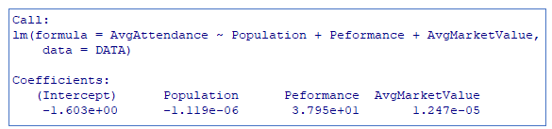
Figure 1- Value of model coefficients
Therefore, the model is:
Where:
- Population = Population of team’s home city
- Performance = Percentage of games won by the team (%)
- AvgMarketValue = Average market value per player on the team

Hypotheses
Before obtaining the model, it was hypothesized that the signs of coefficients would be positive since more victories will attract more fans (higher performance, higher attendance), more popular players attract more fans (higher roster average market value, higher attendance), and the population size of the team’s location will give a potential of more fans attending the games (larger population, higher attendance).
The obtained model did indeed show positive signs for the variables of performance and average roster market value. However, the population coefficient has a negative sign. This could be due to the fact that the popularity of a team does not necessarily depend on the population of its home city.

Results from Regression
The table below shows the standard error for each of the coefficient estimates.
Variable | Coefficient Standard Error
Intercept (constant) | 5.202
Population | 0.000000526
Performance | 11.47
AvgMarketValue | 0.000004567

Econometrics Tests

Overall Significance of the regression (F-test)
For the overall model we have the following hypothesis test:

And we will be using a significance level of . The test output from R is as follows:

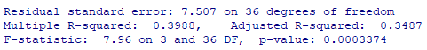
Figure 2- F-test summary
With a p-value of 0.0003374 < 0.05, we reject the null hypothesis. We can conclude that the model is signficant at a signficance level of 0.05.

Coefficient significance (t-tests)
The following table summarizes the individua t-tests for the significance of our three predictors in the model.
Variable | Hypothesis | t-value | p-value
Intercept (constant) |  | -0.308 | 0.75970
Population |  | -2.128 | 0.04029
Performance |  | 3.310 | 0.00213
AvgMarketValue |  | 2.731 | 0.00972

Using a significance level of we can see from the p-values that all coefficients are significant predictors of attendance. The only insignificant coefficient in the model is the intercept.

Multicollinearity
To analyze multicollinearity we analyze the correlation between the variables of interest. The following is a correlation matrix, and Figure 3 shows the correlation matrix for the variables of interest.
AvgAttendance Population Peformance AvgMarketValue
AvgAttendance 1.0000000 -0.2019550 0.4320387 0.4458413
Population -0.2019550 1.0000000 0.1626341 0.1013016
Peformance 0.4320387 0.1626341 1.0000000 0.2296263
AvgMarketValue 0.4458413 0.1013016 0.2296263 1.0000000
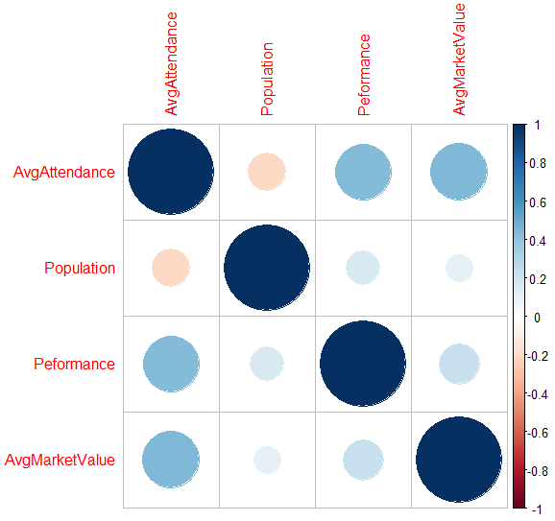
Figure 3- Correlation heat map
We can see that the only highly correlated areas are the self-correlations of each variable. There is no high correlation between the variables, there is no multicollinearity, all correlations are below 0.5 or above -0.5.

Heteroskedasticity (White test)
For White’s Test we have the following hypothesis:
Null: Homoscedasticity is present.
Alternative: Heteroscedasticity is present.
The following is the output of White’s test.
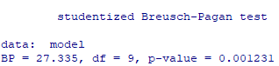
With a p-value of 0.001231,we reject the null hypothesis. We can conclude that Heteroscedasticity is present at a 0.05 significance level.

Conclusion
Even though we obtained a significant model which predicts attendance based on team’s performance, roster average market value, and population of their home city, the model only described 39.88% of the variation in the data. There was no multicollinearity present, however, White’s test determined that heteroscedasticity is present. To build a better model, changes can be made such as increasing sample size by including more seasons or teams and transformation of variables such as log or cosine. There could also be different explanatory variables considered which may be better predictors of game attendance.

References
Global Sports Analytics Market Size Report, 2021-2028. (2021.). https://www.grandviewresearch.com/industry-analysis/sports-analytics-market/methodology.

